[](https://www.iiuc.ac.bd/)

**Final Project**

**Insurance Management System**

**Submission Date- April 30, 2022**

**Course Title- Data Base Management System (Lab)**

**Course Code: CSE-2424**

Submited to-

**Dr. Mohammad Aman Ullah**

**Assistant Professor**

01815641524

[ullah047@yahoo.com](mailto:ullah047@yahoo.com) , [aman_cse@iiuc.ac.bd](mailto:aman_cse@iiuc.ac.bd)

Submitted by-

**MD. SOROWAR MAHABUB RABBY**

Matric ID: ***C201032*,** Section: ***4AM*,** Semester**: *4th***

**Department of CSE (***Computer Science and Engineering***), IIUC**

**Cell:** *01834756433, 01521564157,* [*c201032@ugrad.iiuc.ac.bd*](mailto:c201032@ugrad.iiuc.ac.bd)

**Project Tittle:**

**Insurance Management System**

**Abstract:** The project entitled “**Insurance Management system**” manages the working concept of Life Insurance Corporation. This project is to develop for insurance organization to atomize work technique, utilizing this system to agents and policyholders can know details about present policies, schemes, policy specifications, terms and conditions on the policy, policy registration by the clients. The insurance company needs to keep track of details of its target companies, agents, policyholders, their premium payments and the various products that are available with it. Hence it is under tremendous pressure maintaining their day-to-day activities, which is currently being done manually. Entire records have to be updated timely, even a slight mistake could complicate things. It is very difficult to handle bulk data since human memory is weaker than electronic counterpart. It is time consuming to summarize these details to produce the reports. The Insurance management system is a complete solution for organizations, which need to manage insurance for their vehicles, equipment, buildings, and other resources. Organizes and tracks insurance vendors and the policies provided under different coverage. We are offering a robust webbased insurance solution, which has the flexibility of customizations to match the specific needs of clients for achieving their business goal of good service and revenue generation. Insurance policy administration system consists of a mathematical notation that captures the relationship between policies and objects and the entities that manage policies for those objects. Hence there is need for an automated system, which can efficiently manage the company, records, provides instant access and one that improves the productivity. As a result of this automated system, the activities of the company are performed with in the stipulated time and the reliable and efficient service is ensured to its users.

**Introduction: Insurance Management System** project is a complete solution for organization which needs to manage different type of insurance. Organization can track insurance, premium and policies with this application. Existing manual system of insurance management system takes long time to manage customer insurance records. This online application offers a robust web-based insurance solution.

**ER Model Diagram:**

**Better View:**

[**https://drive.google.com/file/d/1cWtmeN48cufraiixRwapIvwo2uiD57Px/view?usp=sharing**](https://drive.google.com/file/d/1cWtmeN48cufraiixRwapIvwo2uiD57Px/view?usp=sharing)

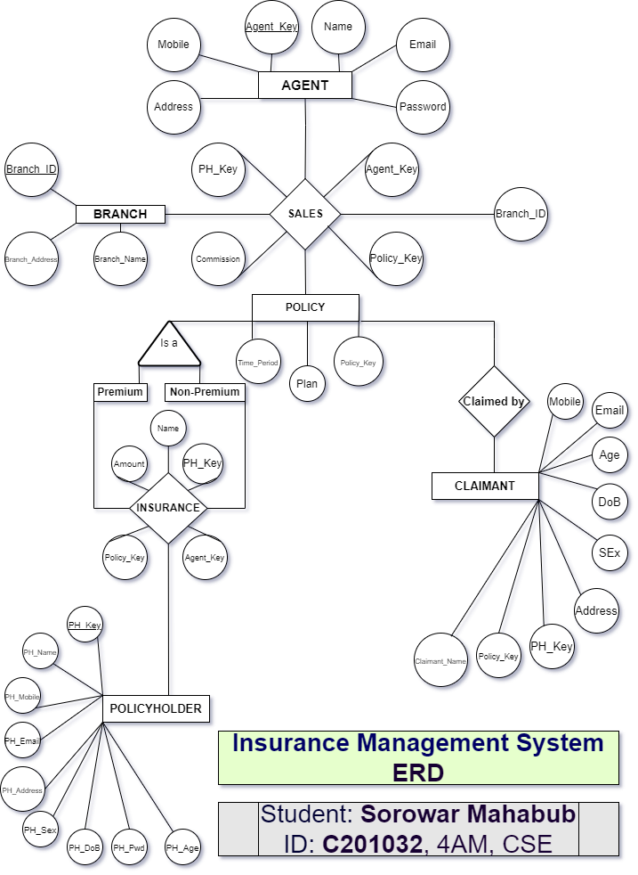

**Scema:**

1. **AGENT** (*Agent_Key*, Name, Password, Mobile, Email, Address)
2. **BRANCH** (*Branch_Id*, Branch_Name, Branch_Address)
3. **CLAIMANT** (Claimant_Name, Policy_Key, Ph_Key, Sex, Dob, Age, Mobile, Email, Address)
4. **INSURANCE** (Agent_Key, Ph_Key, Policy_Key, Insuranced_By(Name), Ammount)
5. **POLICY** (*Policy_Key*, Time_Period, Plan)
6. **POLICYHOLDER** (*Ph_Key*, Ph_Name, Ph_Password, Ph_Sex, Ph_Dob, Ph_Age, Ph_Mobile, Ph_Email, Ph_Address)
7. **SALES** (Agent_Key, Policy_Key, Ph_Key, Branch_Id, Commission)

**DDL Statements & Tables with Data:**

**AGENT**

CREATE TABLE "AGENT"

( "AGENT_KEY" VARCHAR2(4000) NOT NULL ENABLE,

"NAME" VARCHAR2(4000) NOT NULL ENABLE,

"PASSWORD" VARCHAR2(4000),

"MOBILE" VARCHAR2(4000) NOT NULL ENABLE,

"EMAIL" VARCHAR2(4000),

"ADDRESS" VARCHAR2(4000),

CONSTRAINT "AGENT_PK" PRIMARY KEY ("AGENT_KEY") ENABLE

)

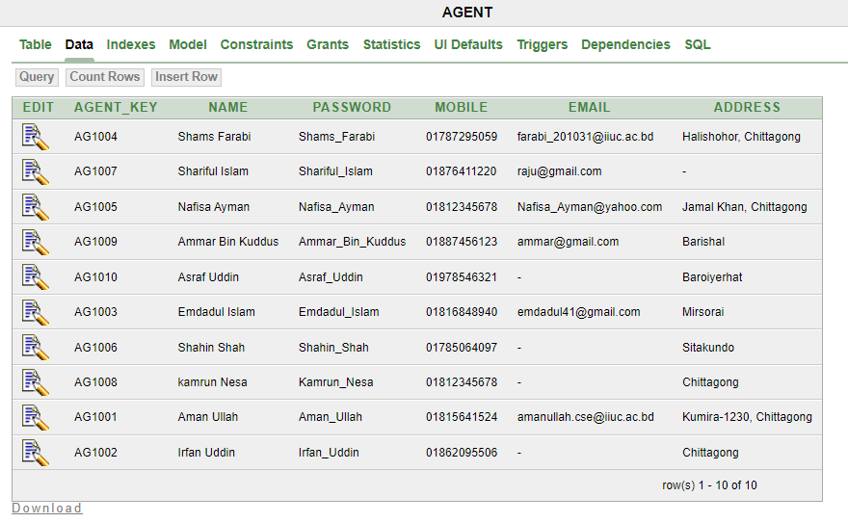

**BRANCH**

CREATE TABLE "BRANCH"

( "BRANCH_ID" NUMBER(10,0) NOT NULL ENABLE,

"BRANCH_NAME" VARCHAR2(4000) NOT NULL ENABLE,

"BRANCH_ADDRESS" VARCHAR2(4000),

CONSTRAINT "BRANCH_PK" PRIMARY KEY ("BRANCH_ID") ENABLE

)

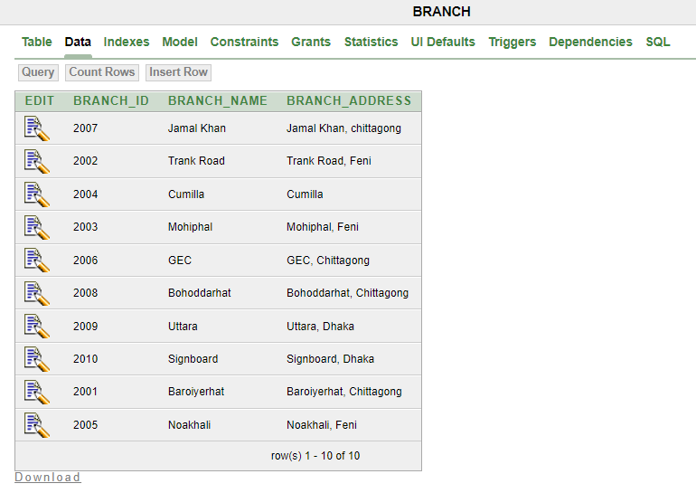

**CLAIMANT**

CREATE TABLE "CLAIMANT"

( "CLAIMANT_NAME" VARCHAR2(4000) NOT NULL ENABLE,

"POLICY_KEY" VARCHAR2(256) NOT NULL ENABLE,

"PH_KEY" VARCHAR2(256) NOT NULL ENABLE,

"SEX" VARCHAR2(4000),

"DOB" DATE NOT NULL ENABLE,

"AGE" NUMBER(10,0) NOT NULL ENABLE,

"MOBILE" VARCHAR2(4000) NOT NULL ENABLE,

"EMAIL" VARCHAR2(4000),

"ADDRESS" VARCHAR2(4000),

CONSTRAINT "CLAIMANT_FK" FOREIGN KEY ("PH_KEY")

REFERENCES "POLICYHOLDER" ("PH_KEY") ENABLE,

CONSTRAINT "CLAIMANT_FK2" FOREIGN KEY ("POLICY_KEY")

REFERENCES "POLICY" ("POLICY_KEY") ENABLE

)

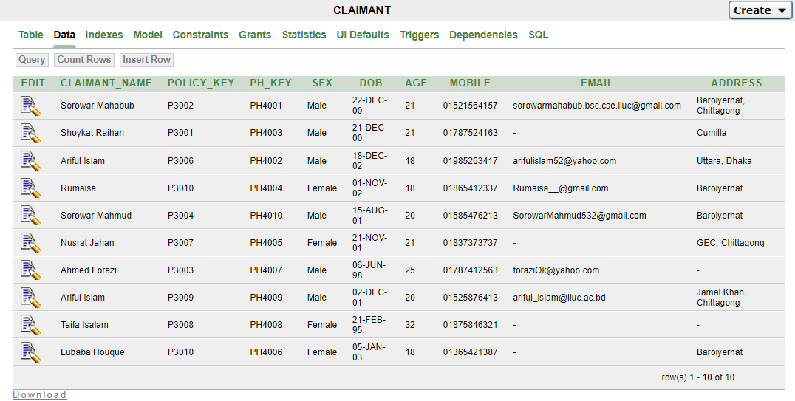

**INSURANCE**

CREATE TABLE "INSURANCE"

( "AGENT_KEY" VARCHAR2(256),

"PH_KEY" VARCHAR2(256),

"POLICY_KEY" VARCHAR2(256),

"INSURANCED_BY(NAME)" VARCHAR2(256) NOT NULL ENABLE,

"AMMOUNT" NUMBER(30,10) NOT NULL ENABLE,

CONSTRAINT "INSURANCE_PK" PRIMARY KEY ("AGENT_KEY", "PH_KEY") ENABLE,

CONSTRAINT "INSURANCE_CK1" CHECK (Ammount>0) ENABLE,

CONSTRAINT "INSURANCE_FK" FOREIGN KEY ("AGENT_KEY")

REFERENCES "AGENT" ("AGENT_KEY") ENABLE

)

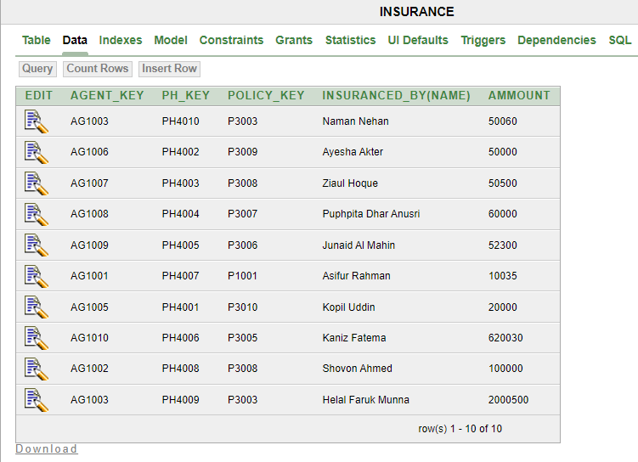

**POLICY**

CREATE TABLE "POLICY"

( "POLICY_KEY" VARCHAR2(4000) NOT NULL ENABLE,

"TIME_PERIOD" VARCHAR2(256) NOT NULL ENABLE,

"PLAN" VARCHAR2(4000) NOT NULL ENABLE,

CONSTRAINT "POLICY_PK" PRIMARY KEY ("POLICY_KEY") ENABLE

)

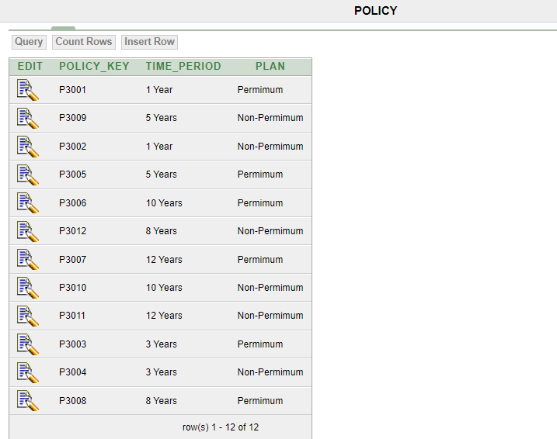

**POLICYHOLDER**

CREATE TABLE "POLICYHOLDER"

( "PH_KEY" VARCHAR2(4000) NOT NULL ENABLE,

"PH_NAME" VARCHAR2(4000) NOT NULL ENABLE,

"PH_PASSWORD" VARCHAR2(4000),

"PH_SEX" VARCHAR2(4000),

"PH_DOB" DATE NOT NULL ENABLE,

"PH_AGE" NUMBER(10,0) NOT NULL ENABLE,

"PH_MOBILE" VARCHAR2(4000) NOT NULL ENABLE,

"PH_EMAIL" VARCHAR2(4000),

"PH_ADDRESS" VARCHAR2(4000),

CONSTRAINT "POLICYHOLDER_PK" PRIMARY KEY ("PH_KEY") ENABLE,

CONSTRAINT "POLICYHOLDER_CK1" CHECK (PH_AGE>17) ENABLE

)

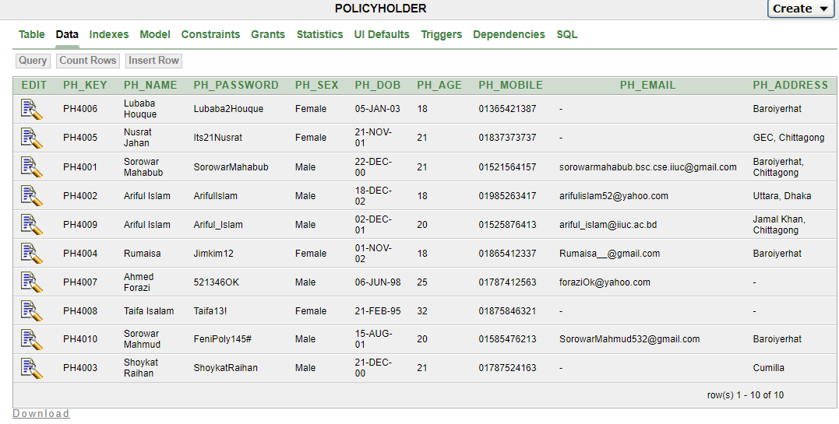

**SALES**

CREATE TABLE "SALES"

( "AGENT_KEY" VARCHAR2(256) NOT NULL ENABLE,

"POLICY_KEY" VARCHAR2(256) NOT NULL ENABLE,

"PH_KEY" VARCHAR2(256) NOT NULL ENABLE,

"BRANCH_ID" NUMBER(10,0),

"COMMISSION" NUMBER(30,10),

CONSTRAINT "SALES_FK" FOREIGN KEY ("AGENT_KEY")

REFERENCES "AGENT" ("AGENT_KEY") ENABLE,

CONSTRAINT "SALES_FK2" FOREIGN KEY ("POLICY_KEY")

REFERENCES "POLICY" ("POLICY_KEY") ENABLE,

CONSTRAINT "SALES_FK3" FOREIGN KEY ("PH_KEY")

REFERENCES "POLICYHOLDER" ("PH_KEY") ENABLE,

CONSTRAINT "SALES_FK4" FOREIGN KEY ("BRANCH_ID")

REFERENCES "BRANCH" ("BRANCH_ID") ENABLE

)

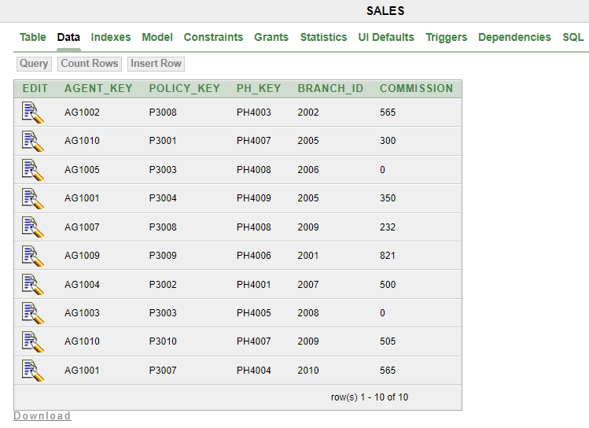

**SEARCHING DATA FROM INDIVIDUAL TABLE** *(At Least 10 Ways)*

**Question-01:** Find Agent information about ‘Shams Farabi’.

**Answer:**

SELECT *

FROM agent

WHERE name='Shams Farabi';

|  |  |  |  |  |  |
| --- | --- | --- | --- | --- | --- |
| **AGENT_KEY** | **NAME** | **PASSWORD** | **MOBILE** | **EMAIL** | **ADDRESS** |
| AG1004 | Shams Farabi | Shams_Farabi | 01787295059 | farabi_201031@iiuc.ac.bd | Halishohor, Chittagong |
| 1 rows returned in 0.00 seconds | | |

**Question-02:** Find the average ammount from Insurance.

**Answer:**

SELECT AVG (ammount)

FROM Insurance;

|  |
| --- |
| **AVG(AMMOUNT)** |
| 301342.5 |
| 1 rows returned in 0.00 seconds |

**Question-03:** Rename the column ‘PH_NAME’ as ‘NAME’ from POLICYHOLDER.

**Answer:**

SELECT PH_NAME, PH_NAME as NAME

FROM POLICYHOLDER;

|  |  |
| --- | --- |
| **PH_NAME** | **NAME** |
| Lubaba Houque | Lubaba Houque |
| Nusrat Jahan | Nusrat Jahan |
| Sorowar Mahabub | Sorowar Mahabub |
| Ariful Islam | Ariful Islam |
| Ariful Islam | Ariful Islam |
| Rumaisa | Rumaisa |
| Ahmed Forazi | Ahmed Forazi |
| Taifa Isalam | Taifa Isalam |
| Sorowar Mahmud | Sorowar Mahmud |
| Shoykat Raihan | Shoykat Raihan |
| 10 rows returned in 0.00 seconds | |

**Question-04:** Find the AGENT_KEY and MOBILE no whose name starts with ‘S’ from AGENT.

**Answer:**

SELECT AGENT_KEY, NAME, MOBILE

FROM AGENT

WHERE NAME LIKE 'S%';

|  |  |  |  |
| --- | --- | --- | --- |
| **AGENT_KEY** | **NAME** | **MOBILE** | |
| AG1004 | Shams Farabi | 01787295059 | |
| AG1007 | Shariful Islam | 01876411220 | |
| AG1006 | Shahin Shah | 01785064097 | |
| 3 rows returned in 0.00 seconds | | |

**Question-05:** Find the details about ‘Sorowar Mahabub’, ‘Taifa Isalam’ and ‘Shoykat Raihan’ from POLICYHOLDER.

**Answer:**

SELECT *

FROM POLICYHOLDER

WHERE PH_NAME IN('Sorowar Mahabub','Taifa Isalam', 'Shoykat Raihan');

|  |  |  |  |  |  |  |  |  |  |
| --- | --- | --- | --- | --- | --- | --- | --- | --- | --- |
| **PH_KEY** | **PH_NAME** | **PH_PASSWORD** | **PH_SEX** | | **PH_DOB** | **PH_AGE** | **PH_MOBILE** | **PH_EMAIL** | **PH_ADDRESS** |
| PH4001 | Sorowar Mahabub | SorowarMahabub | Male | | 22-DEC-00 | 21 | 01521564157 | sorowarmahabub.bsc.cse.iiuc@gmail.com | Baroiyerhat, Chittagong |
| PH4008 | Taifa Isalam | Taifa13! | Female | | 21-FEB-95 | 32 | 01875846321 | - | - |
| PH4003 | Shoykat Raihan | ShoykatRaihan | Male | | 21-DEC-00 | 21 | 01787524163 | - | Cumilla |
| 3 rows returned in 0.00 seconds | | | |

**Question- 06:** Find the Birth Date which POLICYHOLDER are Born in between '20-April-01' AND '31-December-03'.

**Answer:**

SELECT *

FROM POLICYHOLDER

WHERE PH_DOB BETWEEN '20-April-01' AND '31-December-03';

|  |  |  |  |  |  |  |  |  |  |
| --- | --- | --- | --- | --- | --- | --- | --- | --- | --- |
| **PH_KEY** | **PH_NAME** | **PH_PASSWORD** | | **PH_SEX** | **PH_DOB** | **PH_AGE** | **PH_MOBILE** | **PH_EMAIL** | **PH_ADDRESS** |
| PH4006 | Lubaba Houque | Lubaba2Houque | | Female | 05-JAN-03 | 18 | 01365421387 | - | Baroiyerhat |
| PH4005 | Nusrat Jahan | Its21Nusrat | | Female | 21-NOV-01 | 21 | 01837373737 | - | GEC, Chittagong |
| PH4002 | Ariful Islam | ArifulIslam | | Male | 18-DEC-02 | 18 | 01985263417 | arifulislam52@yahoo.com | Uttara, Dhaka |
| PH4009 | Ariful Islam | Ariful_Islam | | Male | 02-DEC-01 | 20 | 01525876413 | ariful_islam@iiuc.ac.bd | Jamal Khan, Chittagong |
| PH4004 | Rumaisa | Jimkim12 | | Female | 01-NOV-02 | 18 | 01865412337 | Rumaisa__@gmail.com | Baroiyerhat |
| PH4010 | Sorowar Mahmud | FeniPoly145# | | Male | 15-AUG-01 | 20 | 01585476213 | SorowarMahmud532@gmail.com | Baroiyerhat |
| 6 rows returned in 0.00 seconds | | |

**Question- 07:** Find the minimum ahe from CLAIMANT.

**Answer:**

SELECT MIN (age)

FROM CLAIMANT;

|  |
| --- |
| **MIN(AGE)** |
| 18 |
| 1 rows returned in 0.00 seconds |

**Question- 08:** Find the summation of all Insurance Amount.

**Answer:**

SELECT SUM (ammount)

FROM Insurance;

|  |
| --- |
| **SUM(AMMOUNT)** |
| 3013425 |
| 1 rows returned in 0.01 seconds |

**Question- 09:** Find the maximum Insurance Amount.

**Answer:**

SELECT MAX (ammount)

FROM Insurance;

|  |
| --- |
| **MAX(AMMOUNT)** |
| 2000500 |
| 1 rows returned in 0.00 seconds |

**Question- 10:** Show all details from Insurance, amount in ascending order.

**Answer:**

SELECT *

FROM Insurance

ORDER BY ammount ASC;

|  |  |  |  |  |  |
| --- | --- | --- | --- | --- | --- |
| **AGENT_KEY** | **PH_KEY** | **POLICY_KEY** | | **INSURANCED_BY(NAME)** | **AMMOUNT** |
| AG1001 | PH4007 | P1001 | | Asifur Rahman | 10035 |
| AG1005 | PH4001 | P3010 | | Kopil Uddin | 20000 |
| AG1006 | PH4002 | P3009 | | Ayesha Akter | 50000 |
| AG1003 | PH4010 | P3003 | | Naman Nehan | 50060 |
| AG1007 | PH4003 | P3008 | | Ziaul Hoque | 50500 |
| AG1009 | PH4005 | P3006 | | Junaid Al Mahin | 52300 |
| AG1008 | PH4004 | P3007 | | Puphpita Dhar Anusri | 60000 |
| AG1002 | PH4008 | P3008 | | Shovon Ahmed | 100000 |
| AG1010 | PH4006 | P3005 | | Kaniz Fatema | 620030 |
| AG1003 | PH4009 | P3003 | | Helal Faruk Munna | 2000500 |
| 10 rows returned in 0.00 seconds | | |

**SEARCHING DATA FROM MULTIPLE TABLE** *(At Least 5 Ways)*

**Question- 01:** List the AGENT_KEY who sells POLICY and show NAME, PH_KEY, POLICY_KEY.

**Answer:**

SELECT agent_key, name, ph_key, policy_key

FROM agent JOIN sales

Using(agent_key);

|  |  |  |  |
| --- | --- | --- | --- |
| **AGENT_KEY** | **NAME** | **PH_KEY** | **POLICY_KEY** |
| AG1004 | Shams Farabi | PH4001 | P3002 |
| AG1007 | Shariful Islam | PH4008 | P3008 |
| AG1005 | Nafisa Ayman | PH4008 | P3003 |
| AG1009 | Ammar Bin Kuddus | PH4006 | P3009 |
| AG1010 | Asraf Uddin | PH4007 | P3010 |
| AG1010 | Asraf Uddin | PH4007 | P3001 |
| AG1003 | Emdadul Islam | PH4005 | P3003 |
| AG1001 | Aman Ullah | PH4004 | P3007 |
| AG1001 | Aman Ullah | PH4009 | P3004 |
| AG1002 | Irfan Uddin | PH4003 | P3008 |
| 10 rows returned in 0.03 seconds | |

**Question- 02:** Those policyholders buy policy whose details showing in the list.

**Answer:**

SELECT p.*,s.policy_key

FROM sales s JOIN policyholder p

ON s.ph_key=p.ph_key;

|  |  |  |  |  |  |  |  |  |  |  |
| --- | --- | --- | --- | --- | --- | --- | --- | --- | --- | --- |
| **PH_KEY** | **PH_NAME** | **PH_PASSWORD** | **PH_SEX** | | **PH_DOB** | **PH_AGE** | **PH_MOBILE** | **PH_EMAIL** | **PH_ADDRESS** | **POLICY_KEY** |
| PH4006 | Lubaba Houque | Lubaba2Houque | Female | | 05-JAN-03 | 18 | 01365421387 | - | Baroiyerhat | P3009 |
| PH4005 | Nusrat Jahan | Its21Nusrat | Female | | 21-NOV-01 | 21 | 01837373737 | - | GEC, Chittagong | P3003 |
| PH4001 | Sorowar Mahabub | SorowarMahabub | Male | | 22-DEC-00 | 21 | 01521564157 | sorowarmahabub.bsc.cse.iiuc@gmail.com | Baroiyerhat, Chittagong | P3002 |
| PH4009 | Ariful Islam | Ariful_Islam | Male | | 02-DEC-01 | 20 | 01525876413 | ariful_islam@iiuc.ac.bd | Jamal Khan, Chittagong | P3004 |
| PH4004 | Rumaisa | Jimkim12 | Female | | 01-NOV-02 | 18 | 01865412337 | Rumaisa__@gmail.com | Baroiyerhat | P3007 |
| PH4007 | Ahmed Forazi | 521346OK | Male | | 06-JUN-98 | 25 | 01787412563 | foraziOk@yahoo.com | - | P3010 |
| PH4007 | Ahmed Forazi | 521346OK | Male | | 06-JUN-98 | 25 | 01787412563 | foraziOk@yahoo.com | - | P3001 |
| PH4008 | Taifa Isalam | Taifa13! | Female | | 21-FEB-95 | 32 | 01875846321 | - | - | P3008 |
| PH4008 | Taifa Isalam | Taifa13! | Female | | 21-FEB-95 | 32 | 01875846321 | - | - | P3003 |
| PH4003 | Shoykat Raihan | ShoykatRaihan | Male | | 21-DEC-00 | 21 | 01787524163 | - | Cumilla | P3008 |
| 10 rows returned in 0.01 seconds | | | |

**Question- 03:** Policyholder name ‘Sorowar Mahabub’ is buying policy whose

details show.

**Answer:**

SELECT policy_key, ph_name, ph_address

mobile, ph_email

FROM sales NATURAL JOIN policyholder

WHERE ph_name = 'Sorowar Mahabub';

|  |  |  |  |  |
| --- | --- | --- | --- | --- |
| **POLICY_KEY** | **PH_NAME** | | **MOBILE** | **PH_EMAIL** |
| P3002 | Sorowar Mahabub | | Baroiyerhat, Chittagong | sorowarmahabub.bsc.cse.iiuc@gmail.com |
| 1 rows returned in 0.02 seconds | |

**Question- 04:** Showing Policy and Insurance all information

**Answer:**

SELECT *

FROM policy p LEFT JOIN insurance i

ON p.policy_key = i.policy_Key;

|  |  |  |  |  |  |  |  |  |
| --- | --- | --- | --- | --- | --- | --- | --- | --- |
| **POLICY_KEY** | **TIME_PERIOD** | **PLAN** | | **AGENT_KEY** | **PH_KEY** | **POLICY_KEY** | **INSURANCED_BY(NAME)** | **AMMOUNT** |
| P3001 | 1 Year | Permimum | | - | - | - | - | - |
| P3009 | 5 Years | Non-Permimum | | AG1006 | PH4002 | P3009 | Ayesha Akter | 50000 |
| P3002 | 1 Year | Non-Permimum | | - | - | - | - | - |
| P3005 | 5 Years | Permimum | | AG1010 | PH4006 | P3005 | Kaniz Fatema | 620030 |
| P3006 | 10 Years | Permimum | | AG1009 | PH4005 | P3006 | Junaid Al Mahin | 52300 |
| P3012 | 8 Years | Non-Permimum | | - | - | - | - | - |
| P3007 | 12 Years | Permimum | | AG1008 | PH4004 | P3007 | Puphpita Dhar Anusri | 60000 |
| P3010 | 10 Years | Non-Permimum | | AG1005 | PH4001 | P3010 | Kopil Uddin | 20000 |
| P3011 | 12 Years | Non-Permimum | | - | - | - | - | - |
| P3003 | 3 Years | Permimum | | AG1003 | PH4009 | P3003 | Helal Faruk Munna | 2000500 |
| P3003 | 3 Years | Permimum | | AG1003 | PH4010 | P3003 | Naman Nehan | 50060 |
| P3004 | 3 Years | Non-Permimum | | - | - | - | - | - |
| P3008 | 8 Years | Permimum | | AG1002 | PH4008 | P3008 | Shovon Ahmed | 100000 |
| P3008 | 8 Years | Permimum | | AG1007 | PH4003 | P3008 | Ziaul Hoque | 50500 |
| 14 rows returned in 0.00 seconds | | |

**Question- 05:** Showing Insurance and Policyholder all information

**Answer:**

SELECT *

FROM policyholder h Right JOIN insurance i

ON h.ph_key = i.ph_key;

|  |  |  |  |  |  |  |  |  |  |  |  |  |  |  |
| --- | --- | --- | --- | --- | --- | --- | --- | --- | --- | --- | --- | --- | --- | --- |
| **PH_KEY** | **PH_NAME** | **PH_PASSWORD** | **PH_SEX** | **PH_DOB** | **PH_AGE** | | **PH_MOBILE** | **PH_EMAIL** | **PH_ADDRESS** | **AGENT_KEY** | **PH_KEY** | **POLICY_KEY** | **INSURANCED_BY(NAME)** | **AMMOUNT** |
| PH4006 | Lubaba Houque | Lubaba2Houque | Female | 05-JAN-03 | 18 | | 01365421387 | - | Baroiyerhat | AG1010 | PH4006 | P3005 | Kaniz Fatema | 620030 |
| PH4005 | Nusrat Jahan | Its21Nusrat | Female | 21-NOV-01 | 21 | | 01837373737 | - | GEC, Chittagong | AG1009 | PH4005 | P3006 | Junaid Al Mahin | 52300 |
| PH4001 | Sorowar Mahabub | SorowarMahabub | Male | 22-DEC-00 | 21 | | 01521564157 | sorowarmahabub.bsc.cse.iiuc@gmail.com | Baroiyerhat, Chittagong | AG1005 | PH4001 | P3010 | Kopil Uddin | 20000 |
| PH4002 | Ariful Islam | ArifulIslam | Male | 18-DEC-02 | 18 | | 01985263417 | arifulislam52@yahoo.com | Uttara, Dhaka | AG1006 | PH4002 | P3009 | Ayesha Akter | 50000 |
| PH4009 | Ariful Islam | Ariful_Islam | Male | 02-DEC-01 | 20 | | 01525876413 | ariful_islam@iiuc.ac.bd | Jamal Khan, Chittagong | AG1003 | PH4009 | P3003 | Helal Faruk Munna | 2000500 |
| PH4004 | Rumaisa | Jimkim12 | Female | 01-NOV-02 | 18 | | 01865412337 | Rumaisa__@gmail.com | Baroiyerhat | AG1008 | PH4004 | P3007 | Puphpita Dhar Anusri | 60000 |
| PH4007 | Ahmed Forazi | 521346OK | Male | 06-JUN-98 | 25 | | 01787412563 | foraziOk@yahoo.com | - | AG1001 | PH4007 | P1001 | Asifur Rahman | 10035 |
| PH4008 | Taifa Isalam | Taifa13! | Female | 21-FEB-95 | 32 | | 01875846321 | - | - | AG1002 | PH4008 | P3008 | Shovon Ahmed | 100000 |
| PH4010 | Sorowar Mahmud | FeniPoly145# | Male | 15-AUG-01 | 20 | | 01585476213 | SorowarMahmud532@gmail.com | Baroiyerhat | AG1003 | PH4010 | P3003 | Naman Nehan | 50060 |
| PH4003 | Shoykat Raihan | ShoykatRaihan | Male | 21-DEC-00 | 21 | | 01787524163 | - | Cumilla | AG1007 | PH4003 | P3008 | Ziaul Hoque | 50500 |
| 10 rows returned in 0.00 seconds | | | | | |

**SUB-QUERIES**

**Question- 01:** Find who earn same COMMISSION as whose BRANCH_ID=2008.

**Answer:**

SELECT AGENT_KEY, COMMISSION

FROM SALES

WHERE COMMISSION=(SELECT COMMISSION

FROM SALES

WHERE BRANCH_ID=2008);

|  |  |  |
| --- | --- | --- |
| **AGENT_KEY** | **COMMISSION** | |
| AG1005 | 0 | |
| AG1003 | 0 | |
| 2 rows returned in 0.00 seconds | |

**Question- 02:** Find which Insurance Amount same as Amount=10035.

**Answer:**

SELECT PH_KEY, POLICY_KEY, AMMOUNT

FROM INSURANCE

WHERE AMMOUNT=(SELECT AMMOUNT

FROM INSURANCE

WHERE AMMOUNT=10035);

|  |  |  |  |
| --- | --- | --- | --- |
| **PH_KEY** | **POLICY_KEY** | **AMMOUNT** | |
| PH4007 | P1001 | 10035 | |
| 1 rows returned in 0.00 seconds | | |

**Question- 03:** Find the PH_KEY, PH_NAME, PH_AGE whose PH_AGE=21.

**Answer:**

SELECT PH_KEY, PH_NAME, PH_AGE

FROM POLICYHOLDER

WHERE PH_AGE IN( SELECT PH_AGE

FROM POLICYHOLDER

WHERE PH_AGE=21);

|  |  |  |  |
| --- | --- | --- | --- |
| **PH_KEY** | **PH_NAME** | **PH_AGE** | |
| PH4005 | Nusrat Jahan | 21 | |
| PH4001 | Sorowar Mahabub | 21 | |
| PH4003 | Shoykat Raihan | 21 | |
| 3 rows returned in 0.00 seconds | | |

**Question- 04:** Find AGENT_KEY, POLICY_KEY, PH_KEY, BRANCH_ID, COMMISSION

more than 500.

**Answer:**

SELECT AGENT_KEY, POLICY_KEY, PH_KEY, BRANCH_ID, COMMISSION

FROM SALES

WHERE COMMISSION > (SELECT COMMISSION

FROM SALES

WHERE COMMISSION= 500);

|  |  |  |  |  |
| --- | --- | --- | --- | --- |
| **AGENT_KEY** | **POLICY_KEY** | **PH_KEY** | **BRANCH_ID** | **COMMISSION** |
| AG1002 | P3008 | PH4003 | 2002 | 565 |
| AG1009 | P3009 | PH4006 | 2001 | 821 |
| AG1010 | P3010 | PH4007 | 2009 | 505 |
| AG1001 | P3007 | PH4004 | 2010 | 565 |
| 4 rows returned in 0.00 seconds | |

**Question- 05:** Find the PH_KEY, PH_NAME, PH_AGE whose PH_AGE is not 21.

**Answer:**

SELECT PH_KEY, PH_NAME, PH_AGE

FROM POLICYHOLDER

WHERE PH_AGE NOT IN( SELECT PH_AGE

FROM POLICYHOLDER

WHERE PH_AGE=21);

|  |  |  |  |
| --- | --- | --- | --- |
| **PH_KEY** | **PH_NAME** | **PH_AGE** | |
| PH4006 | Lubaba Houque | 18 | |
| PH4002 | Ariful Islam | 18 | |
| PH4009 | Ariful Islam | 20 | |
| PH4004 | Rumaisa | 18 | |
| PH4007 | Ahmed Forazi | 25 | |
| PH4008 | Taifa Isalam | 32 | |
| PH4010 | Sorowar Mahmud | 20 | |
| 7 rows returned in 0.00 seconds | | |

**QUERIES WITH PL/SQL**

**Question- 01:** Show the details about agent whose BRANCH_ID=2002.

**Answer:**

DECLARE

AID SALES.agent_key%type;

PHID SALES.PH_KEY%type;

COM SALES.COMMISSION%type;

BEGIN

SELECT agent_key, PH_KEY, COMMISSION INTO AID, PHID, COM

FROM SALES

WHERE BRANCH_ID=2002;

dbms_output.put_line('Agent Details-');

dbms_output.put_line('Agent_ID : '|| AID);

dbms_output.put_line('PolicyHolder_ID : '|| PHID);

dbms_output.put_line('Agent_Comission : '|| COM);

END;

**Output:** 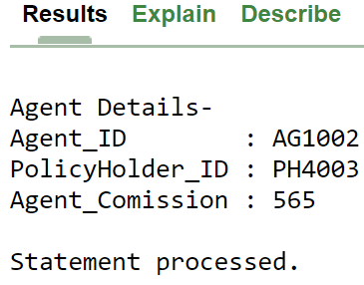

**Question- 02:** Show the brief details of all Insurance .

**Answer:**

DECLARE

cu_record INSURANCE%rowtype;

cursor cu IS

SELECT*

FROM INSURANCE;

BEGIN

OPEN cu;

dbms_output.put_line('Brief of all Insurance: ');

dbms_output.put_line(' ');

LOOP

FETCH cu INTO cu_record;

EXIT WHEN cu%notfound;

dbms_output.put_line('Agent_ID : '|| cu_record.AGENT_KEY );

dbms_output.put_line('PolicyHolder_ID : '|| cu_record.PH_KEY );

dbms_output.put_line('Policy_ID : '||cu_record.POLICY_KEY );

dbms_output.put_line('Insurance_Amount :'|| cu_record.AMMOUNT );

dbms_output.put_line('.............................');

END LOOP;

CLOSE cu;

END;

**Output:**

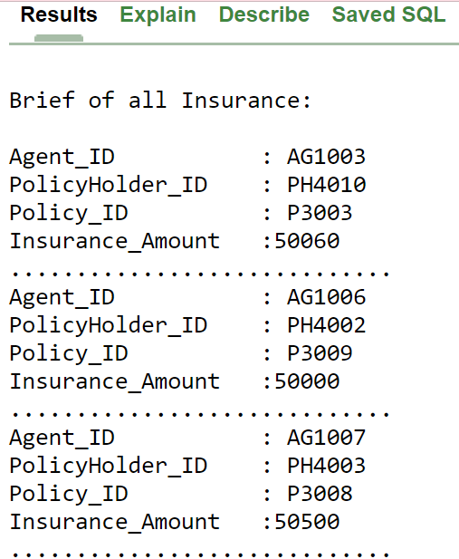

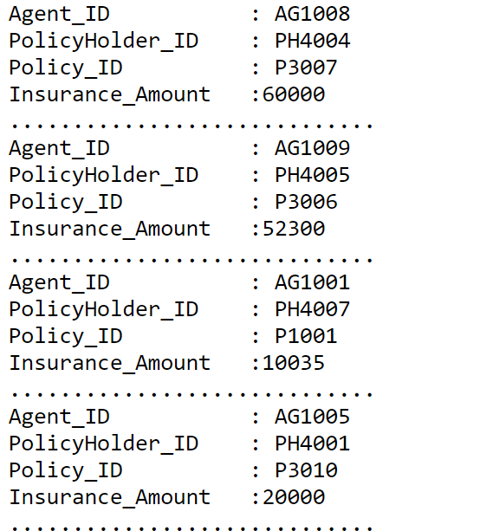

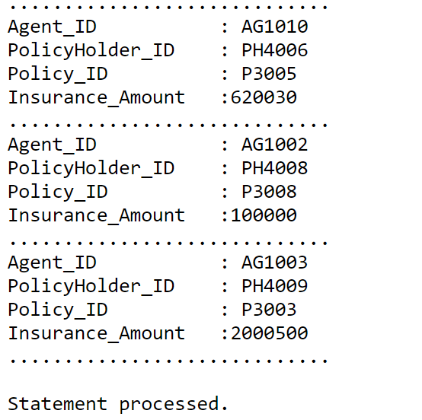

**Question- 03:** Show the details of all Policyholders.

**Answer:**

DECLARE

cu_record POLICYHOLDER%rowtype;

cursor cu IS

SELECT*

FROM POLICYHOLDER;

BEGIN

OPEN cu;

dbms_output.put_line('PolicyHolders Details: ');

dbms_output.put_line(' ');

LOOP

FETCH cu INTO cu_record;

EXIT WHEN cu%notfound;

dbms_output.put_line('ID : '|| cu_record.PH_KEY);

dbms_output.put_line('Name : '|| cu_record.PH_NAME);

dbms_output.put_line('Gender : '||cu_record.PH_SEX);

dbms_output.put_line('Mobile :'|| cu_record.PH_MOBILE);

dbms_output.put_line(' ');

END LOOP;

CLOSE cu;

END;

**Output:**

PolicyHolders Details:

ID : PH4006

Name : Lubaba Houque

Gender : Female

Mobile :01365421387

ID : PH4005

Name : Nusrat Jahan

Gender : Female

Mobile :01837373737

ID : PH4001

Name : Sorowar Mahabub

Gender : Male

Mobile :01521564157

ID : PH4002

Name : Ariful Islam

Gender : Male

Mobile :01985263417

ID : PH4009

Name : Ariful Islam

Gender : Male

Mobile :01525876413

ID : PH4004

Name : Rumaisa

Gender : Female

Mobile :01865412337

ID : PH4007

Name : Ahmed Forazi

Gender : Male

Mobile :01787412563

ID : PH4008

Name : Taifa Isalam

Gender : Female

Mobile :01875846321

ID : PH4010

Name : Sorowar Mahmud

Gender : Male

Mobile :01585476213

ID : PH4003

Name : Shoykat Raihan

Gender : Male

Mobile :01787524163

Statement processed.

**Question- 04:** Find the brief details of CLAIMANT having age more than 20.

**Answer:**

CREATE OR REPLACE procedure maxage(a IN number,b IN varchar2,d IN varchar2)

as

BEGIN

IF a>20 THEN

dbms_output.put_line(' ');

dbms_output.put_line('CLAIMANT NAME=> '||b||'|| POLICY KEY:=> '||d||' || AGE:=> '||a);

END IF;

END;

**Output- 01:**

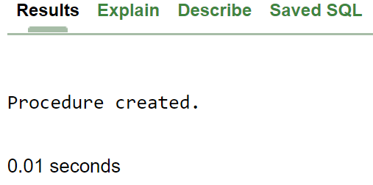

DECLARE

a number;

b varchar2(20);

c varchar2(25);

d varchar2(20);

cl_record CLAIMANT%rowtype;

cursor cl IS

SELECT*

FROM CLAIMANT;

BEGIN

OPEN cl;

dbms_output.put_line('Employees having salary more than

300:');

LOOP

FETCH cl INTO cl_record;

EXIT WHEN cl%notfound;

a:= cl_record.age;

b:= cl_record.CLAIMANT_NAME;

d:= cl_record.POLICY_KEY;

maxage(a,b,d);

END LOOP;

CLOSE cl;

END;

**Output- 02:** 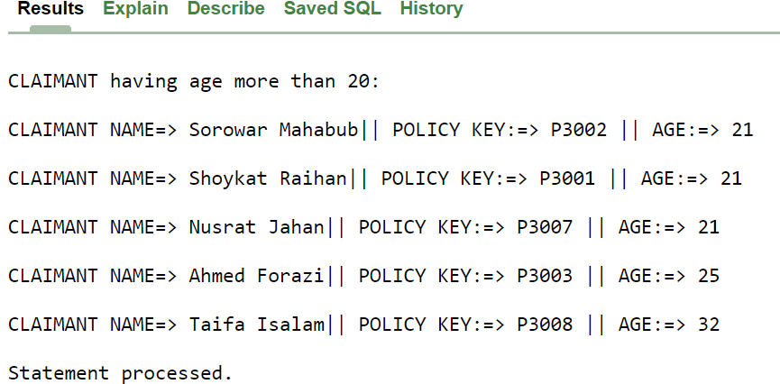

**Question- 05:** Find the brief details of Insurance having amount less than 50000.

**Answer:**

CREATE OR REPLACE procedure maxamount(a IN number,b IN varchar2,d IN varchar2)

as

BEGIN

IF a<50000 THEN

dbms_output.put_line(' ');

dbms_output.put_line('AGENT KEY:=>'||b||'||PolicyHolder KEY:=>

'||d||'|| AMOUNT:=> '||a);

END IF;

END;

**Output- 01:**



DECLARE

a number;

b varchar2(20);

c varchar2(25);

d varchar2(20);

i_record INSURANCE%rowtype;

cursor i IS

SELECT*

FROM INSURANCE;

BEGIN

OPEN i;

dbms_output.put_line('Insurance having amount less than 50000:');

LOOP

FETCH i INTO i_record;

EXIT WHEN i%notfound;

a:= i_record.AMMOUNT;

b:= i_record.AGENT_KEY;

d:= i_record.PH_KEY;

maxamount(a,b,d);

END LOOP;

CLOSE i;

END;

**Output- 02:** 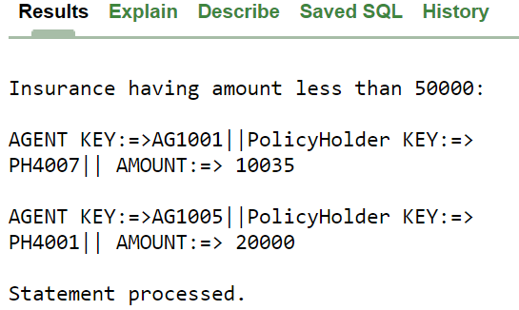

**The End!**

**Assalamualaikum Waa RahmatullaH Waa Barkatuhu**

Submitted by-

**MD. SOROWAR MAHABUB RABBY**

Matric ID: **C201032**, Section: 4**AM**

Department of CSE (Computer Science and Engineering)